Lesson 9 intro to hooks

<https://www.youtube.com/watch?v=JgYRBCRHfHE&list=PL4cUxeGkcC9hNokByJilPg5g9m2APUePI&index=9>

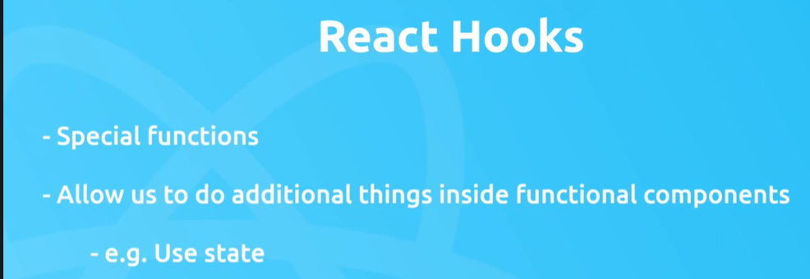

No longer have to use class components, can use better functional components for this.

Some of the different hooks in react are :